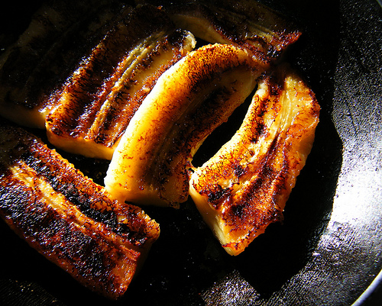

**Ndizi Kaanga**

This is a recipe for Fried banana’s or plantains. This is a very simple and delicious recipe that many use to cook in Tanzania. Enjoy

Ingredients:

* 8 whole plantains or green bananas, peeled
* Lemon juice
* Brown sugar (optional)
* Butter, melted
* Nutmeg

Method:

1. Melt butter in a frying pan.
2. Cut and quarter the bananas or plantains.
3. Dip the banana pieces in lemon juice and place them in the buttered frying pan.
4. Lightly brown, remove, and drain on paper towels. Sprinkle with nutmeg and brown sugar, if desired. (*Ndizi*is typically not sweetened in Tanzania.)

Serves 8 to 10.

Enjoy